Sri Sri University

Final Project Report

On

Customer Behavior Analysis

Team members:

M.S.L.V. Saranya

Aditya Narayan Panda

Sonali Nanda

Bhandari Sree Shivani

Guided by: Dr. Chinmaya Kumar Nayak

Industry Mentor:

Sumit Shukla

Table of Contents

1. Executive Summary 3
2. Background 4
   1. Aim 4
   2. Technologies 4
   3. Software Architecture 4
3. System 5-6
   1. Functional Requirements 5
   2. GUI Layout 5-6
4. Snapshots 7-9
5. Conclusions 10
6. Further Development and Research 10
7. References 11

**Executive Summary**

Customer Behavior Analysis is a project intended to help businesses understand their customers better. It creates dashboards based on customer data which gives valuable insights in the form of graphical method for easier understanding. The project comprises of a frontend made with SvelteKIT, backend using Django, and sqlite3 database. The dataset used for the project consists 5 lakh customer data points which will be used to create two types of dashboards:

1. Individual Dashboard: Dashboard for individual customers
2. Grouped Dashboard: Dashboard based on any attribute and its value

In the backend, Django will be responsible for handling the data. Database was created as db.sqlite3 inside the Django app. Data was migrated from the combination of two csv files having 250000 data points each.

Django Rest Framework was used to retrieve data from the database, convert it to json format and return it using various apis. In total 11 apis were constructed using ListAPIView() as per the requirements.

The frontend fetches data from the backend and produces graphs to create the dashboard.

**Background**

**2.1. Aim**

This project is created to help understand the customer data in an easier manner by creating dashboards.

**2.2. Technologies**

Technologies used in this project are :

* + SvelteKIT
  + Django
  + Django Rest Framework
  + Sqlite3

**2.3. Software Architecture**

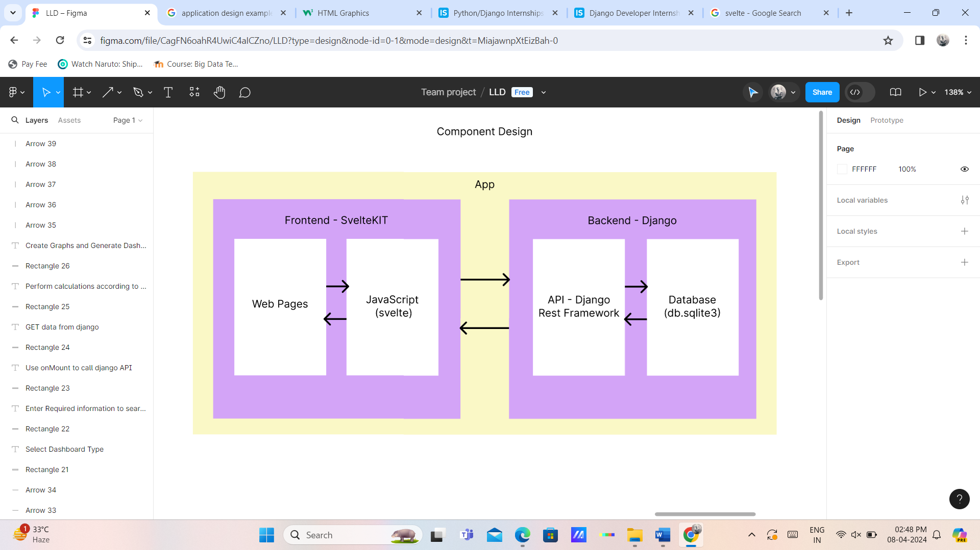

**System**

**3.1. Functional Requirements**

The functional requirements include:

* Python
* Django
* DjangoRest Framework
* Sqlite3
* SvelteKIT
* Chart.js

**3.2. GUI Layout**

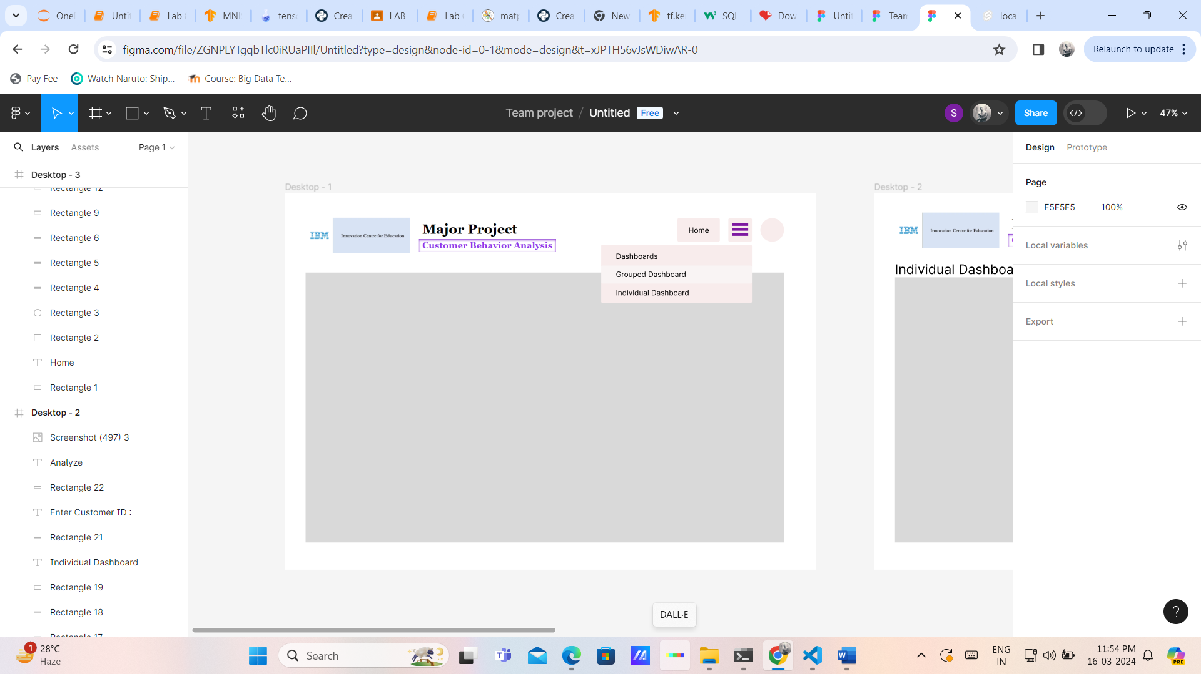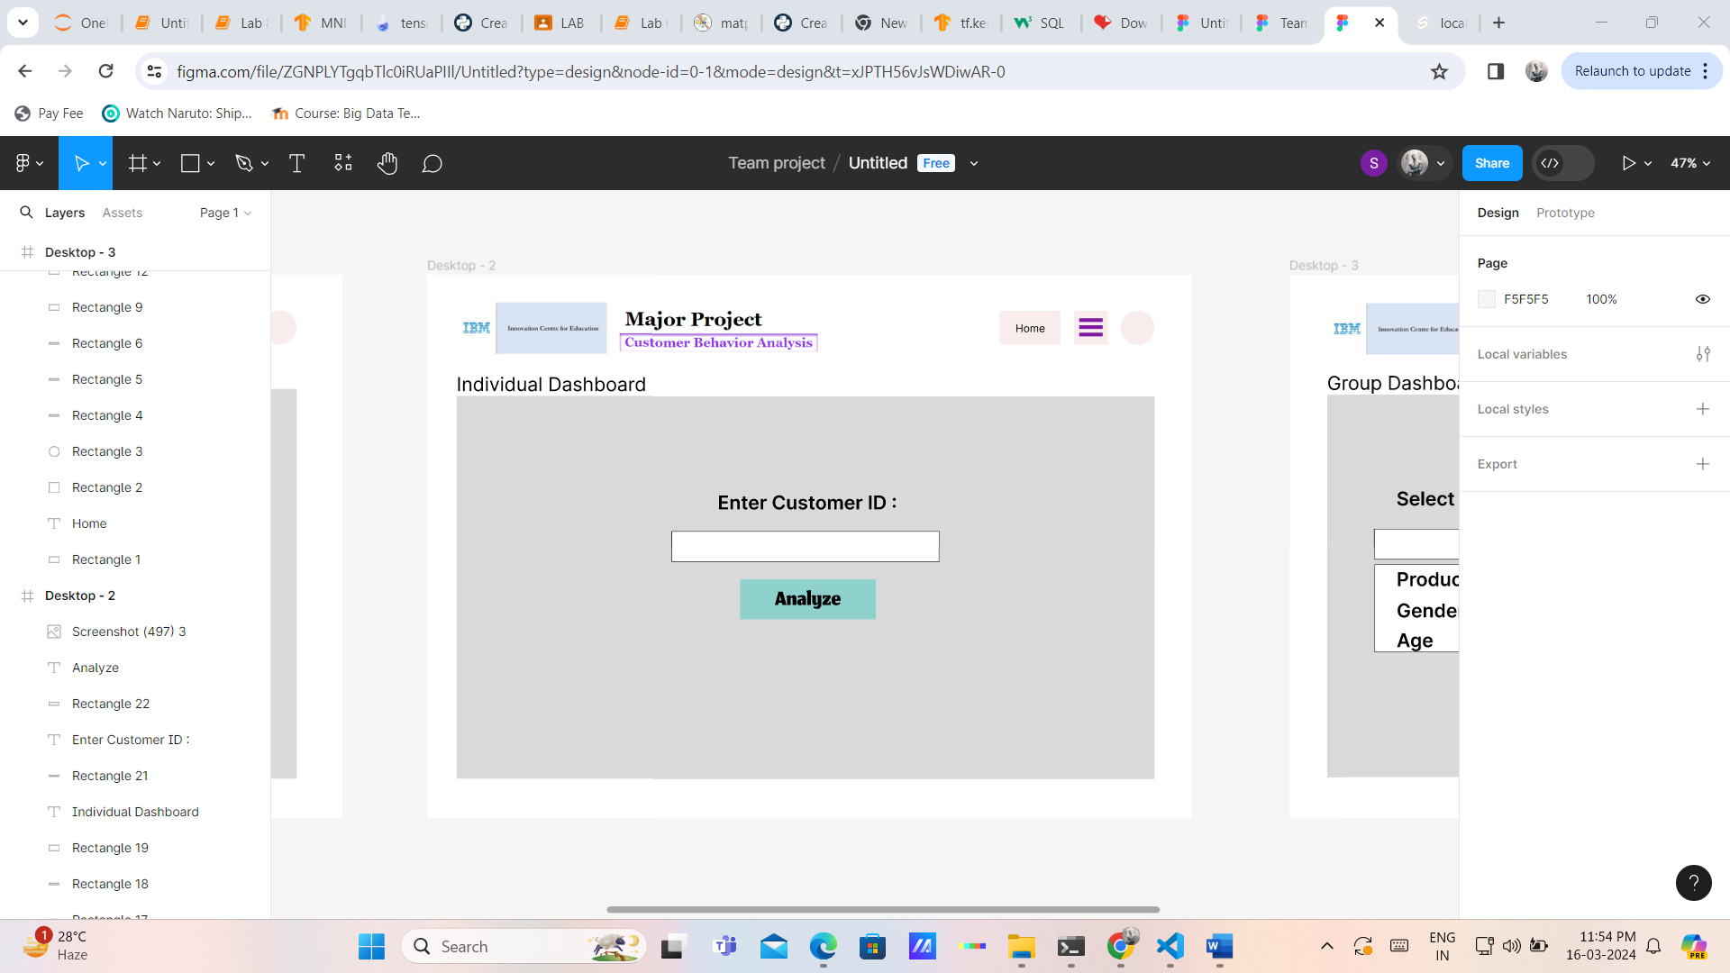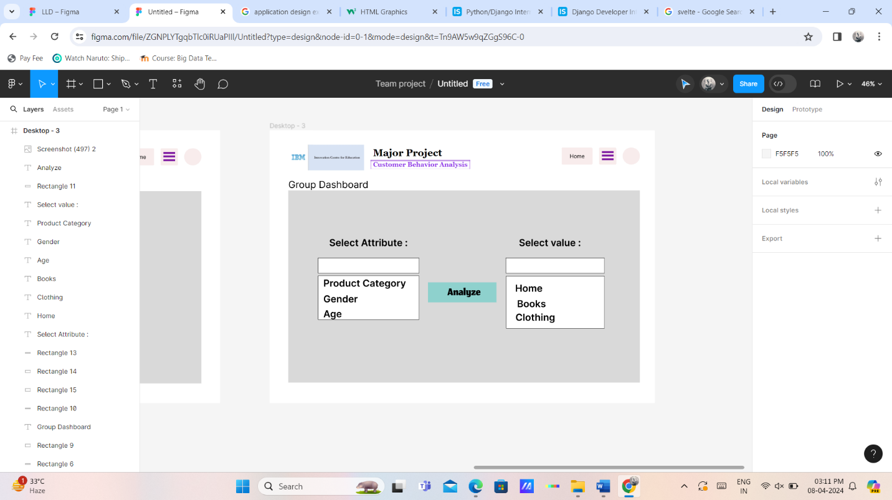

**Snapshots**

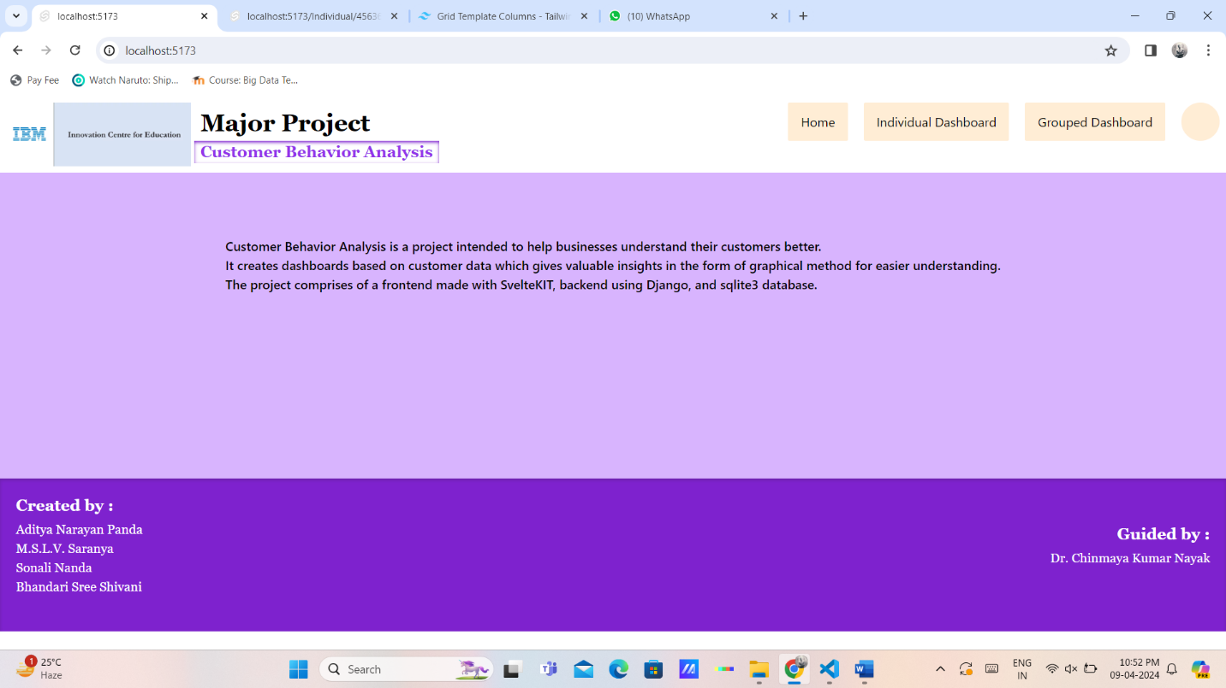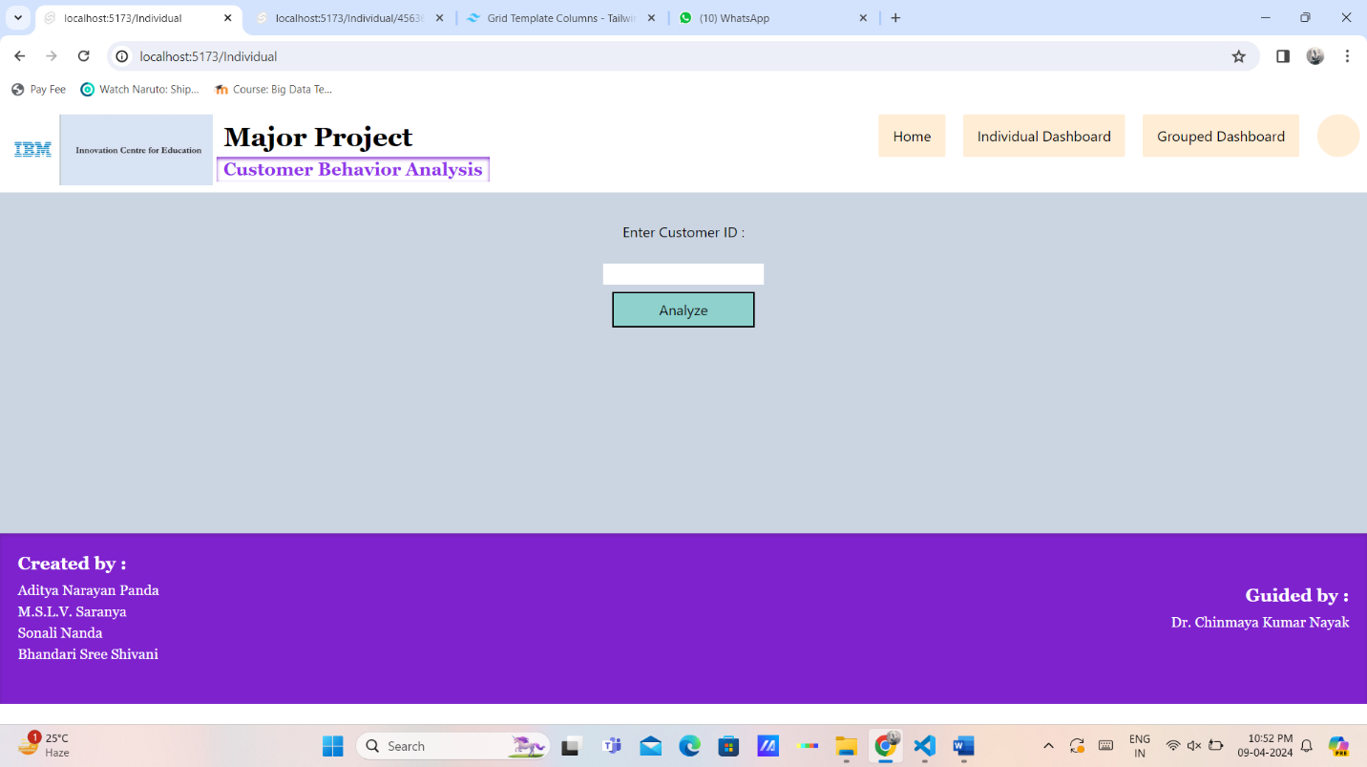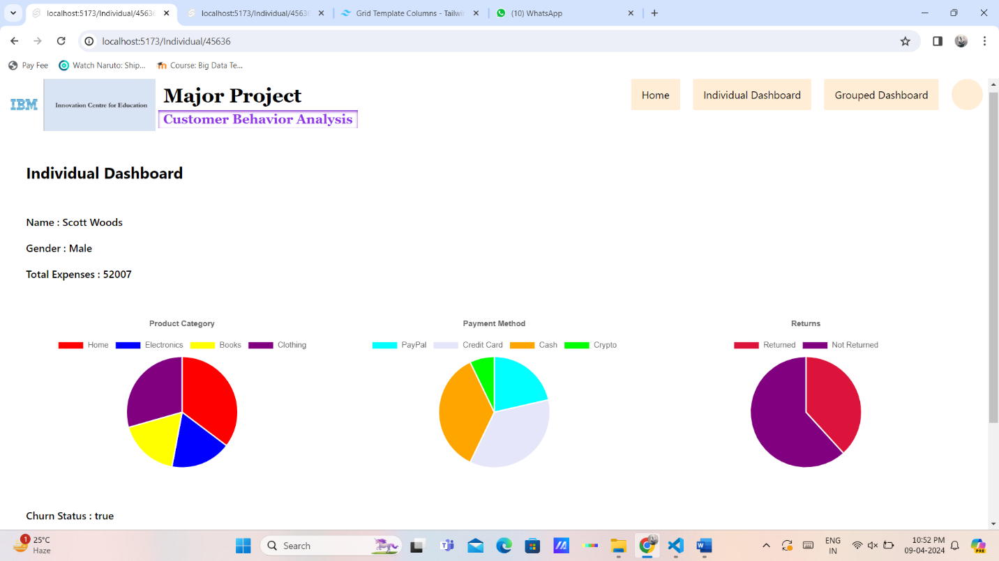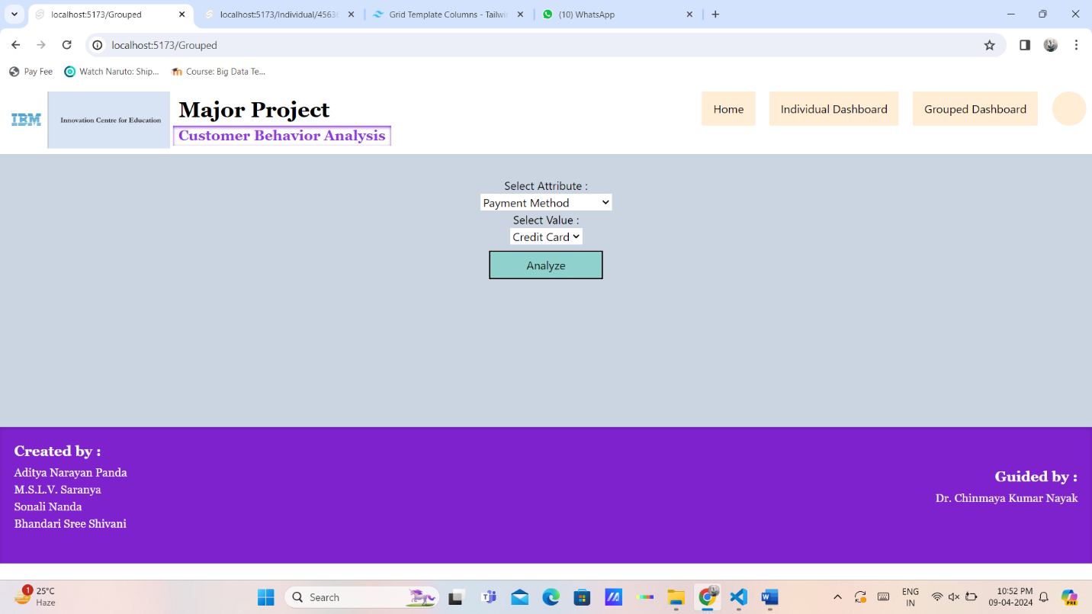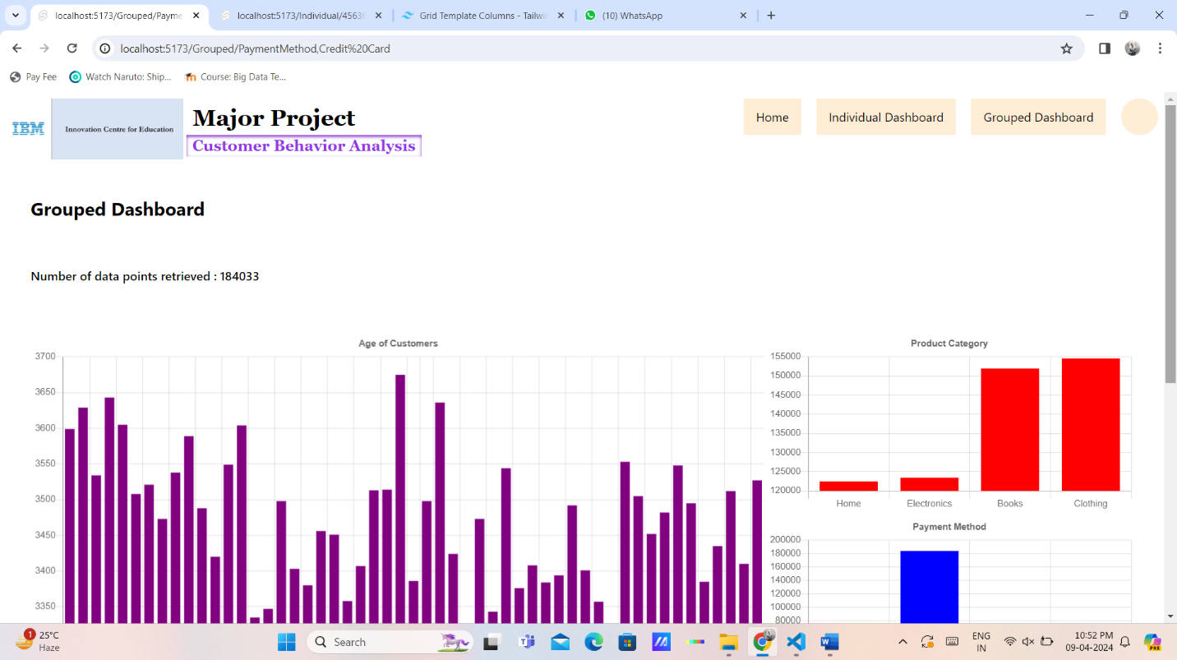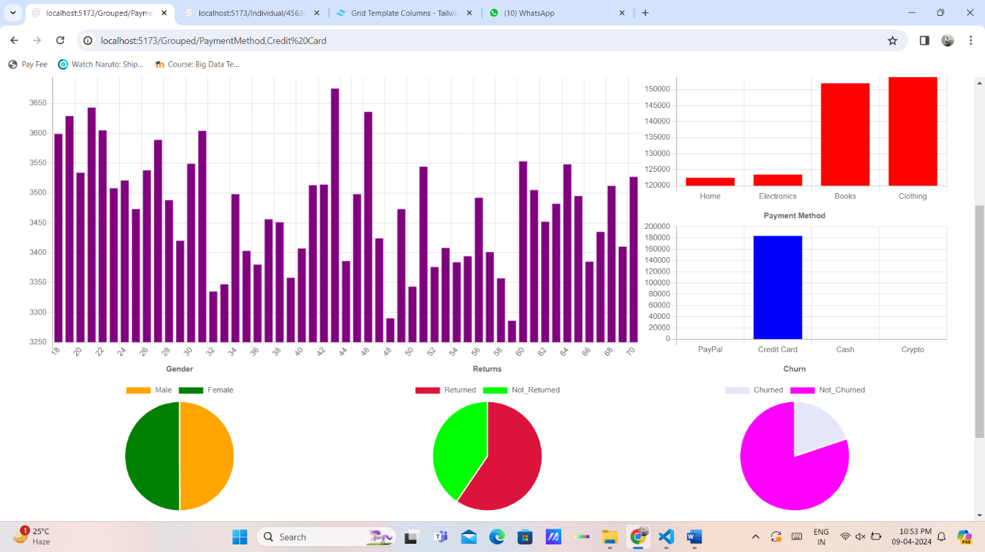

**Conclusions**

* The project can help businesses to analyze and make strategies based on the customer data
* SvelteKIT is a great framework for Dynamic Web Applications
* Django can work with large load of data smoothly.

**Further Development and Research**

This was a prototype based on synthetic data. This project can help future clients to discuss about tailoring the project particularly as per their requirements.

**References**

* <https://kit.svelte.dev/docs/introduction>
* <https://docs.djangoproject.com/en/5.0/>
* <https://www.django-rest-framework.org/>